Autonomously Initiating Drone Security

David Cain - Nicole McCrary - Bobby Miniex

Project Description

The Goal of this project is to Create a Drone capable of approaching a disturbance and detecting an intruder within a commercial setting. The drone will avoid objects in its way in order to approach the supposed disturbance. It will then, using a camera, detect the intruder and transmit video to a base station. In the event an intruder.

Components list

1. Pixhawk
2. Raspberry pi
3. ESC’s
4. Motors
5. Propellers
6. GPS/Compass
7. Drone Frame
8. Ultrasonic Sensors
9. Propeller guards
10. Camera
11. RC receiver
12. RC controller
13. Wireless Router
14. Battery
15. Mission Planner

Block Diagram

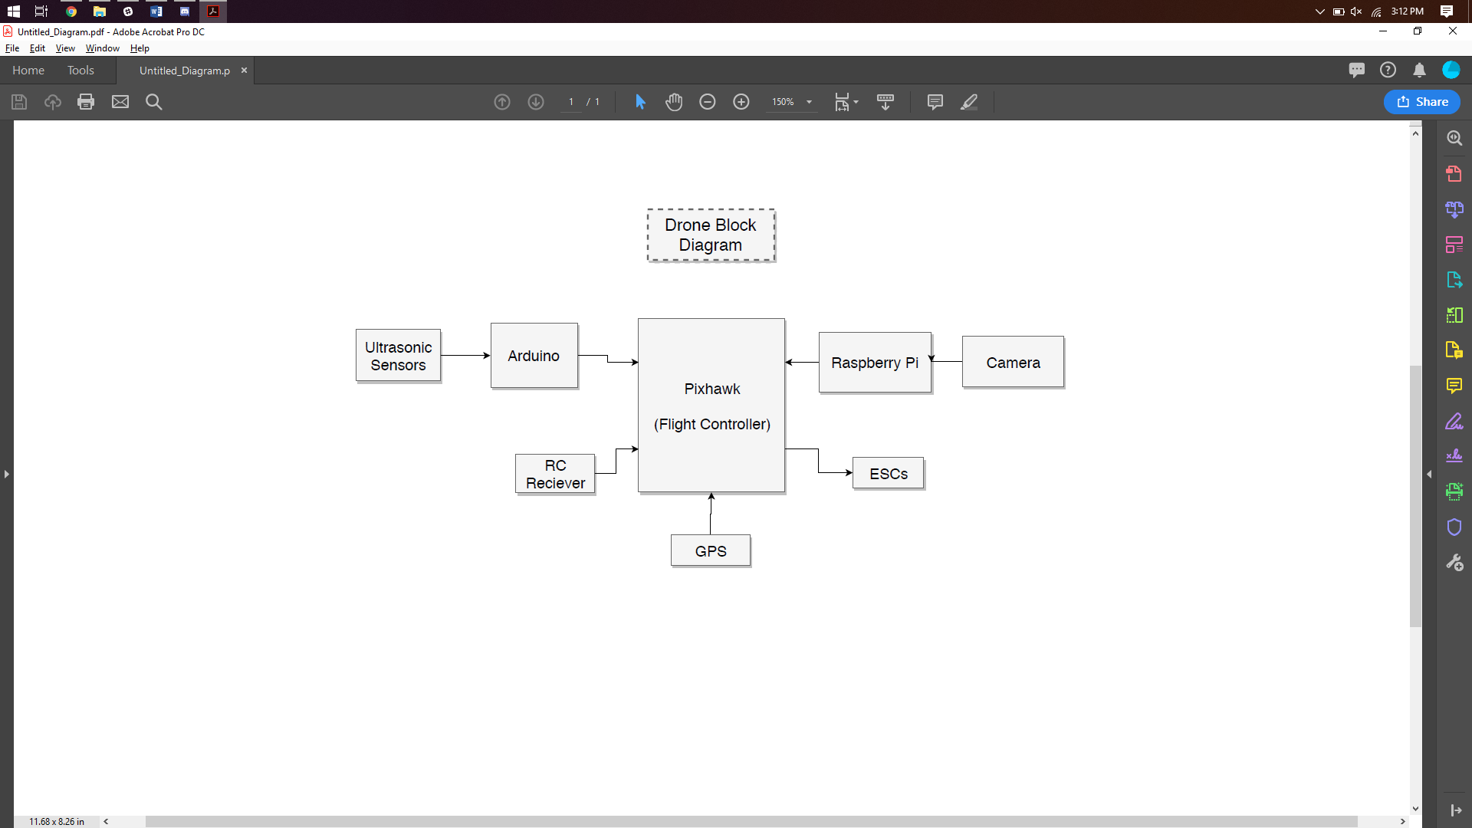

Finite State Machine

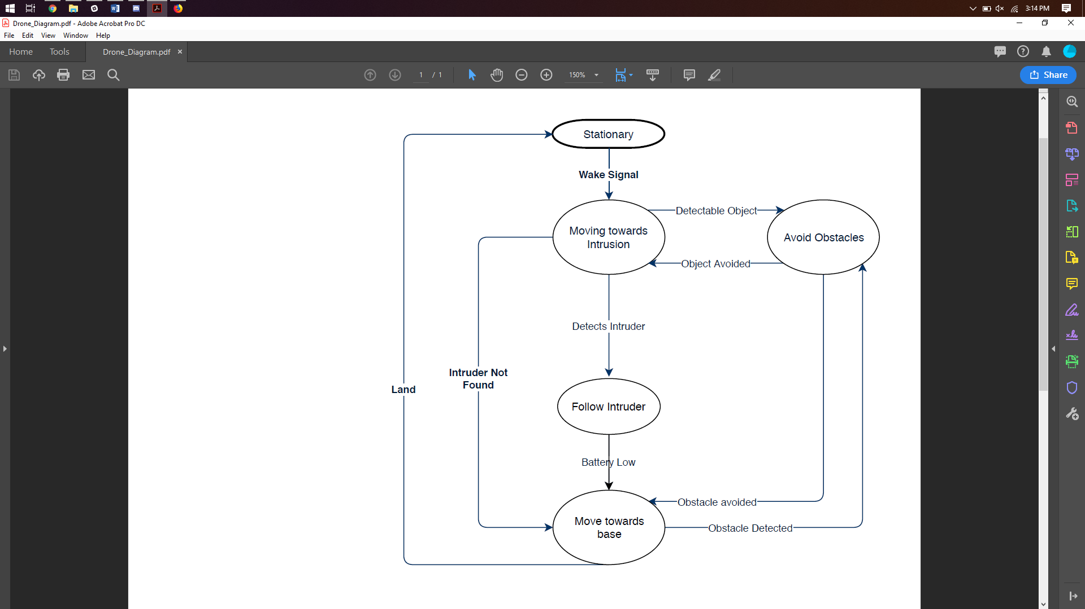

Machine Learning Model

1. Legs
2. Arms
3. Height

Phases

Phase 1

The goal of phase one is to get the drone flying, simple object avoidance code working, and have the beginning steps of intruder recognition working.

Phase 2

Phase two includes the hopefully successful testing of returning to base, Following the intruder, and proper data transmission over a wireless network. Other stretch goals would include speeding up the code efficiency wise and looking into other hardware alternatives.

Roles

Bobby: Get Base drone working and aid Other members in interfacing with pixhawk. Making the drone safe.

David: complete pathing implementation.

Nicole: get image processing/ recognition working on pi (eventually work on open-cv based pathing)

All: figure out how to attempt implementing the pi based features onto the fpga.

Challenges

1. Safety
2. Potential Hardware interfacing complications. Ie. Arduino hardware limitations
3. Drone flight tuning
4. Camera movement-based issues.
5. Potential ultrasonic sensor inaccuracy
6. GPS indoor issues